Vehicle : Used for transport - runs on ground (not rails)

Motor vehicles : Cars, Trucks, Buses, Motorcycles, Mopeds

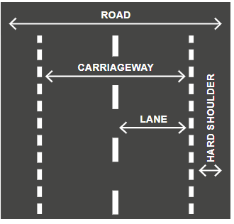

Hard shoulder or verge

* Safety zone
* Primarily be used by pedestrians, cyclists, moped drivers and slow-moving vehicles.
* You may drive briefly on it to facilitate an overtaking or turning only with good visibility.
* Vehicles on the hard shoulder have an obligation to give way to vehicles on the carriageway

Basic speed limits, which may be of help if there are no signs/road sign destroyed/has snow:

* Built-up area: 50 km/h.
* Outside of built-up area: 70 km/h.

Legally required to maintain sufficiently low speed adapted to the situation :

* Densely built-up areas
* Pedestrian crossings
* Bad visibility (weather, turns, slopes)
* Slippery roads or bad roads (splashing risk)
* Cross-traffic
* Meeting other vehicles on narrow roads
* Approaching children, animals, roadworks in progress, accident
* Approaching bus/tram/school bus that has stopped to let passengers get in/off

Prohibited to drive excessively slowly or brake suddenly without cause

Right to drive at high speeds and not follow traffic rules when necessary :

Police, Health-care, Rescue, Customs/officials etc.

Reversible lanes (===) are very rare

**Precedence**

Police signals (including a traffic director and similar).

Traffic signals.

Road signs.

Rules (the priority-to-the-right rule, etc.).

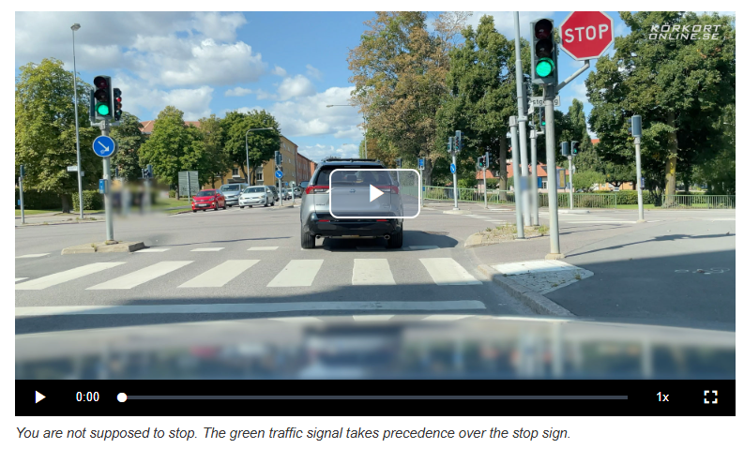

If police was here and there was red light and stop, but she still signals to keep driving, you do despite the red light or stop sign

Priority road :

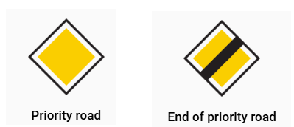

* Erected at the start of the priority road and is repeated after each junction
* There is a general parking prohibition on priority roads, which means that you are only allowed to park in marked parking spaces.
* There is, however, no general stopping prohibition on priority roads, which means that you are allowed to **stop to load or unload** goods or to allow a passenger to get in or out of the car

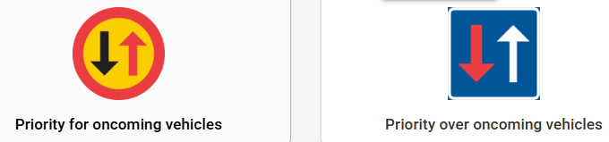

You may choose the lane that is most suitable for your continued journey if

* there are at least two marked lanes for traffic in your direction
* and speed limit is 70 km/h or lower

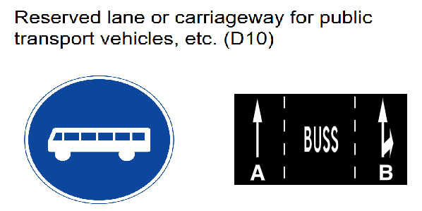

* Can be used by all only to cross
* Bicycles and class II mopeds (not EU mopeds class I) can use it.
* If any other vehicles are permitted to use it, this is specified on an additional panel.

STOP sign

* **Stop just before the stop line. If there is no stop line, stop just before entering the intersecting road**. Sometimes this means passing the stop sign before stopping, as the sign may be several metres before the junction.
* If there is a queue, each car must still come to a stop at the stop line
* Not respecting the obligation to stop is a serious violation. You can lose your licence if you continue creeping forwards instead of stopping.
* All-way stop means that all the adjoining roads have an obligation to stop. The easiest solution is for whoever stopped first to also start driving again first. All-way stops are rare.

The priority-to-the-**right rule**

* Applies at any time when vehicles cross paths (even in open areas and parking)
* At junctions between a private road and a regular public road, if there are no road signs denoting priority road/obligation to give way, it is the right rule that applies
* Does not apply when other rules exist
* Does not apply during reversing

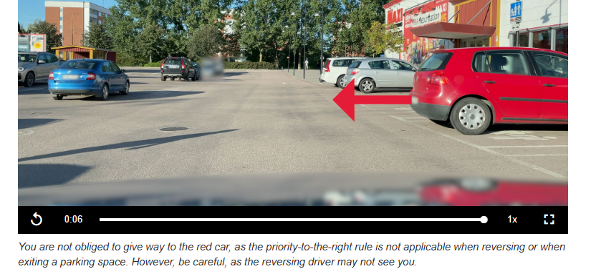

Turning rule

* Give way when turning at a junction.
* Do not obstruct oncoming and existing road users (including pedestrians/cyclists even if there is no pedestrian crossing). This obligation to pedestrians is milder than, for example, your duty to give way to pedestrians at pedestrian crossings. You do not have to stop and wait for pedestrians who are approaching the junction and are about to cross, as you must do at pedestrian crossings. However, be careful and keep in mind that pedestrians and cyclists are unprotected road users.

Obstacle rule

* Driver with obstacle on their side should give way

Obstruction rule

* Never stop at a junction, on a pedestrian crossing or similar.

**Always Give way to and do not obstruct**:

* Emergency vehicles (ambulances, police cars and fire engines) with sirens and/or flashing blue lights turned on
* Trains and trams.
* Military convoys
* Processions of different kinds (such as children with teachers and funeral processions)

Exit rule

* Give way while exiting
  + car park
  + property, petrol station
  + hard shoulder
  + pedestrian street, home zone, bicycle street

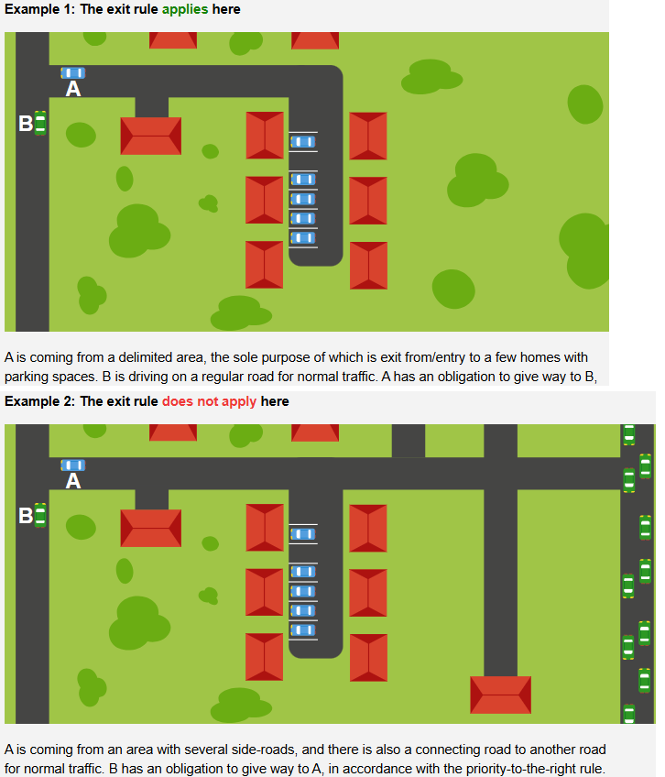

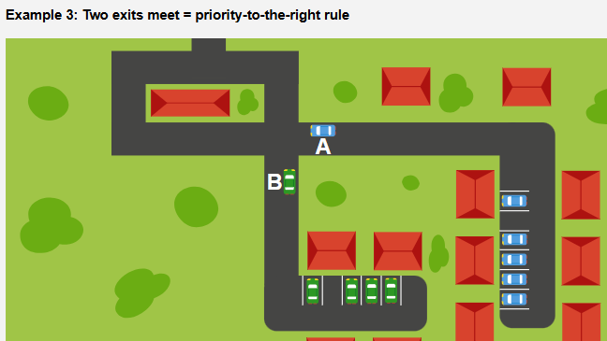

Bus rule

* 50 km/h or slower: You must give way to the bus if it indicates to exit (only applicable to the lane furthest to the right)

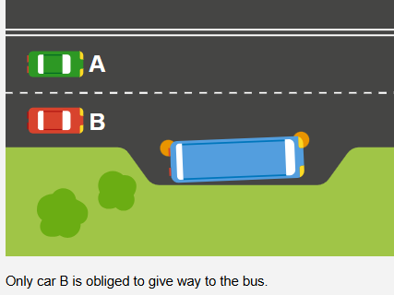

* Over 50 km/h: The bus must give way to you.

Roundabout

* **Give way** to all those **already driving in** the roundabout.
* You are only allowed to change lanes if you can do so without obstructing or endangering other road users.
* Facilitate other drivers’ lane changes by adapting your speed.
* **Try** to **exit** from the **right**-most lane

Vehicle may be towed away if rules are broken and if

* Parked where it is unsafe, blocks traffic or hinders road maintenance
* Not suitable for traffic (e.g. driving ban, wreck or unpaid debts)



Visibility in darkness :

|  | Full beam headlights | Dipped headlights |
| --- | --- | --- |
| Dark clothing NO reflectors | 150 m | 25 m |
| Light clothing NO reflectors | 300 m | 60 m |
| YES reflectors | 450 m | 125 m |

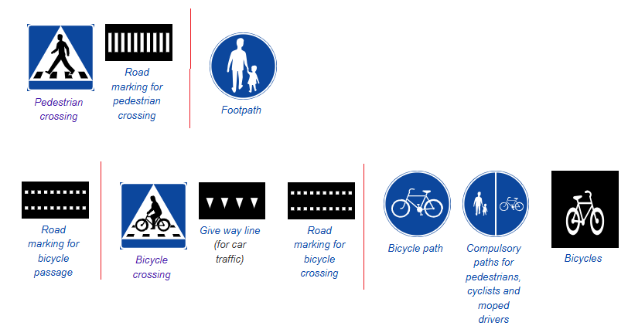

| *Pedestrian Crossing* | *Footpath* | *Bicycle passage* | *Bicycle crossing* | *Bicycle paths* |
| --- | --- | --- | --- | --- |
| Sign and/or road marking | **Cars** can only **cross + should give way** | Often combined with PC | **Cars - give way** | **Cars** can only **cross + should give way** |
| Seek eye contact | * Cyclists * Electric scooters * Class II mopeds | Don’t drive >30 kmph |
| Don’t wave over if multiple lanes |
| Controlled PC   * Traffic signals or police | Controlled BP |
| Uncontrolled PC   * CPC if signals are not functioning * **Car - give way** - show intent (reduce speed/ stop) | Uncontrolled BP   * **Cyclists - give way** to car * **Car turning - Car give way** * Cars let cyclists already on BP pass |

* Pedestrians hit by car at 30 kmph have 90% survival rate, and 20% at 50 kmph

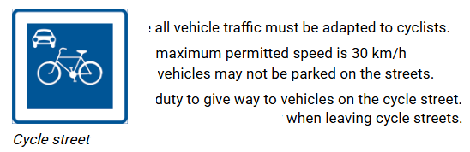

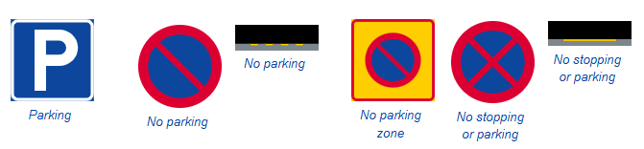

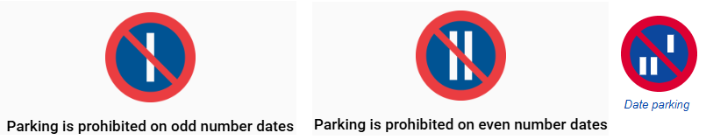

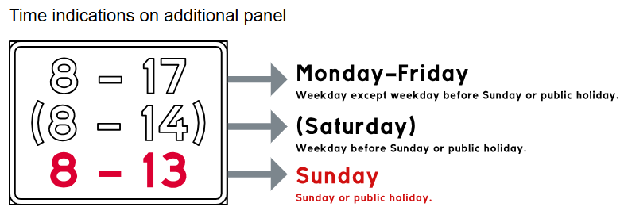

| *Parking* | *No parking* | *No stopping or parking* |
| --- | --- | --- |
| Parking = Halting other than avoiding danger/required by traffic conditions/loading, unloading near car/dropoff, pickup   * P = Park for **max 24 hrs on weekdays (Monday-Saturday)**. NO time limit on saturday (or day before public holiday) and sunday ( public holiday) * Set the parking disc to nearest half-an-hour * Prohibited to leave the car keys in a parked car * Disabled parking - only by those with permit. If no permit, you can only drop-off/pickup * If you park on the side of a road in the dark, you must turn on your parking lights so that other road users can see your car. * Turn the wheels on an uphill or downward slope to prevent the car from rolling out   **Up**hill slope: **Away** from the kerb  Downhill: Towards   * No parking zone : Exception: Parking is permitted where a parking sign is displayed in the zone * Date parking :   Even-numbered dates: NO parking on the side of the road with even house numbers  Odd-numbered dates   * As long as you do not obstruct a bus or tram, drop-off and pickup (but not load/unload) - 20 metres before and 5 metres after bus stop if unmarked | NO P at   * Within 30m of level crossing * Priority road if there is no parking sign * If blocking someone’s exit * Next to another vehicle side-by-side (called double parking) * If one of the wheels is outside a parking space * At a passing place (M sign) * LHS of the road   Exception 1: One-way street. Exception 2: If RHS has tracks | Stopping = Halting other than parking/avoiding danger/required by traffic conditions  NO S/P at   * At a junction and within 10 metres from the junction * Within 10 metres before a pedestrian crossing (can stop/park after 10m.) * Where you obscure visibility or roadsigns * In tunnel * Roundabout * Motorway/Clearway * On a road where there is a solid centre line on your side, if there is less than 3 metres between your car and the line * In a bus lane * In a bicycle lane * At level crossings * On public places that are off-road (e.g. grass) within built-up areas. |

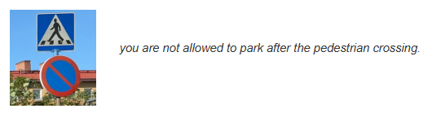

Country Road

* A good distance to maintain from the car in front of you on a country road is 100m.
  + 3-second rule (1001..)
  + 3 verge posts between (distance between two white verge posts is 50 metres)
  + Change your speed in km/h to metres - so, 90m when travelling at 90 km/h
* If the car behind you is too close, you can reduce the risks by maintaining a large distance from the car in front of you. Or pull over into an appropriate lay-by or parking space, and allow the stressed driver to pass.

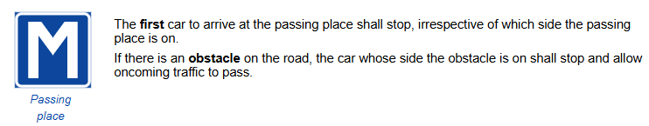

* Verge posts with reflectors
  + Distance between verge posts is normally 50 metres (100 metres on motorways, 25 metres in bends).
  + The reflectors are white if the road continues without interruption. At junctions, bus stops and parking spaces, the reflectors are yellow.
  + On the left side of the road, the reflectors are round to warn of oncoming traffic. On the right side of the road, the reflectors are rectangular.
  + On motorways, the reflectors are rectangular on both sides, as there is no oncoming traffic.

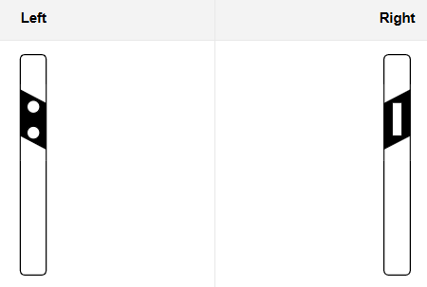

Motorways

* Both exit and entry slip roads are part of the motorway, which means that the same rules apply to them
* Motorway entry slip roads
  + If there is an **acceleration lane**, **neither** those in the acceleration lane nor those already on the motorway have **priority**. Mutual consideration and adaptation apply.
  + If there is no acceleration lane, those entering have an obligation to give way to traffic already on the motorway.
  + Leave the entry slip road as soon as you can
* Vehicles <=40 kmph are forbidden (incl.Class I mopeds (45 kmph))
* Towing is forbidden

Clearways

* Mix of motorway and country road.
* Same rules and prohibitions as on motorways apply.
* No intersecting traffic, but oncoming traffic may occur (rare, cable barriers are often used).
* Accidents occur more frequently than on motorways (shorter entry slip roads, less space to the sides).

Overtaking

* Once you have overtaken, you must return to your original lane as soon as possible
* Rejoin the lane once you can see the car you have overtaken in the right side mirror
* You are obliged to assist the car overtaking you (if the hard shoulder is empty, you can drive on it to make things easier), even if manoeuvre is prohibited or dangerous
* Trams are normally overtaken on the right
* Roadwork vehicles may be overtaken on the most suitable side
* You are not allowed to break the speed limit when overtaking.
* No overtaking
  + If someone behind or in front is overtaking or is about to do so.
  + If you would need to cross the centre line and there is oncoming traffic or limited visibility.
  + Uncontrolled PC, BP, BC
    - Exception: Passing at low speed (so that you are able to stop) is permitted if there is more than one lane in your direction and one of the following conditions is met: The lanes have different destinations. There is heavy queuing in all lanes. It takes place at a junction.
  + On the right-hand side
    - Exception 1: Permitted if the lanes have different destinations
    - Exception 2: if there is heavy queuing in all lanes.
    - Exception 3: if the vehicles are in separate lanes at a junction
    - Exception 4: if the speed limit is <=70 kmph and there are at least two marked lanes going in the same direction
    - Exception 5: Permitted if the other vehicle is turning left.
  + Junction where the right rule applies, or other junctions where you have an obligation to give way
    - Exception 1: Permitted to overtake two-wheeled vehicles
    - Exception 2: Permitted to pass on the right if the other vehicle is turning left.
  + Railway crossings with no barriers or 3-colored traffic signals. Exception: Permitted to overtake two-wheeled vehicles.
* Over 90 km/h: If you increase speed by 10 kmph, you gain 30 sec every 10 km. Below 90 km/h: If you increase speed by 10 km/h, you will gain 1 minute every 10 km.
* Accelerating overtaking : Drive closely behind at the same speed. Pull out and increase your speed quickly (within the speed limit) to pass the car
* (Better) **Flying overtaking** means : Approach at high speed and change lanes in good time before driving past - requires a shorter distance (as well as using less fuel)

Slippery road

* Winter
  + A lot of snow and ice = not treacherous, as the danger is evident. Patches of ice = treacherous, as the danger is hidden.
  + Drive on snow tracks as you may get good traction inside them, but if you go outside them you may lose the grip on the road completely. You should therefore avoid overtaking in these conditions.
  + Freezing rain = When the temperature is around 0°C, rain may freeze directly upon contact with the road -> Extremely slippery roads
  + Snow smoke : While snowing, tyres in front whisk up the newly fallen snow. So, maintain an extra large distance
  + Snow markers (long red poles) indicate the actual width of the road.
  + How to discover ice on the road
    - Temperature lower than +4°C
    - No splashing heard from under the car when road looks wet/damp
    - At a junction, snow is often densely compressed by passing cars, which increases the risk of ice
    - Shaded sections
    - Bridges and viaducts as they are cooled by the air from below and above
  + Winter equip. : Outerwear, Snow shovel, Ice scraper, Towline, Starter cables
* Spring : Melting snow and ice
* Autumn : Ice
* Summer : Tar in asphalt, or oil remnants

Aquaplaning

* Car floats on water as they cant disperse all of the water from beneath it and thereby do not make contact with the road
* Wider tyres mean that more water needs to be pushed aside, which leads to a greater risk of aquaplaning.
* High speed, or tyres with poor tread depth also increase the risk of Aqp
* If you begin Aqp, DO NOT STEER, DO NOT BREAK, and RELEASE ACCELERATOR

Car’s Weight

* Private car = Driver + max 8 passengers
* Kerb/Service Weight = Car + Full fuel tank (no passengers/cargo)
* Unladen weight = KW + Driver (max 75 kg)
* Maximum load = Given in registration certificate (incl. non-driver weights + cargo)
* Total weight = Unladen weight + Maximum load
  + **Category B License Requirement:** 
    - **Trailer's TW ≤ 750 kg** (so, Car 3,500 kg + trailer 750 kg = 4,250 kg) **OR**
    - **If Trailer’s TW>750 kg, then max TW (i.e., car+trailer TW) ≤ 3.5 tons**
* Gross weight = Actual weight at this moment (including KW, current load/passengers)

Speed table

| 25 | Class 2 moped |
| --- | --- |
| 30 | * A-tractor (EPA car) * Non-tow truck towing another   + If on motorways/clearways, DON’T tow by yourself - instead call tow truck   + Can have hazard lights on towed car and not on towing veh.   + Dark : Towed car with no lights should be marked - WHITE reflectors and lamp at the front, and red at the back * Class 2 motorised eq. (construction eq.) |
| 40 | * Tractor type a * If trailer has no brakes, and its total weight (trailer + any load) is **more** than half of car’s kerb/service weight |
| 45 | Class 1 (EU) moped |
| 50 | * Class 1 motorised eq. (construction eq.) * Tractor type b |
| 80 | * Car’s trailer with brakes * If trailer has no brakes, and its total weight (trailer + any load) is **less** than half of car’s kerb/service weight * Motorcycle with trailer * Heavy truck on other roads * Heavy truck with trailer |
| 90 | * Heavy truck on motorway/clearway * Heavy bus (TW > 3.5 tons) without seat belts |
| 100 | Heavy bus (TW > 3.5 tons) with seat belts |
| ? | * Light truck * Light bus (TW <= 3.5 tons) * Motorcycle |

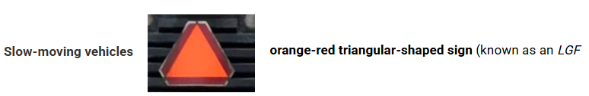

* Speed = 30, 40, 45 kmph
* 4 wheeled vehicles have this sign

Roof boxes

* Avoid loading heavy items (Roof box + Roof racks + Cargo <= 100 kg)

Level crossings

* Point where train/tram intersects with road

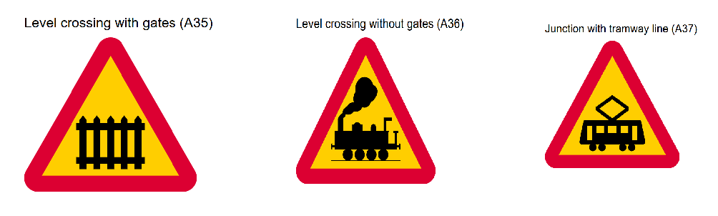

* Train/Tram crossing

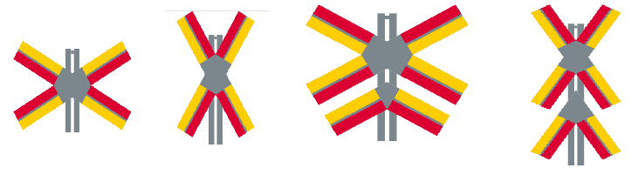

* Single/multiple tracks
* Placed just before level crossing
* Not usually placed on private road even if there is level crossing

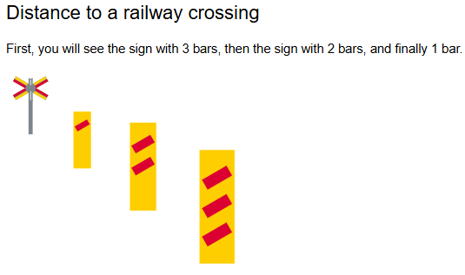

* Tracks are uneven, so slow down if you are driving > 70 kmph
* When you’re driving in the countryside or less populated areas, you’ll usually see the three-bar distance marker placed under one of the level crossing signs
* In cities or towns, they usually don’t put these extra distance-bar signs
* Level crossing signals :

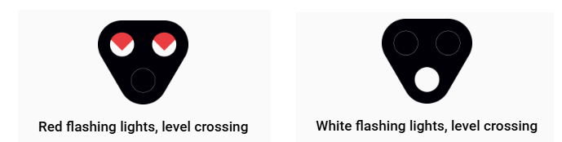

* Special railway signals found at some supervised level crossings
* Red = Stop, White = Go
  + White lights are there to make the railway crossing easier to detect. They do not mean that it is safe to proceed. If a train is approaching, you must give way, even if the lights are not flashing red.

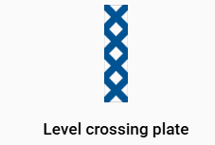

* Used to make a level crossing more visible
* Where used, they are usually positioned to the right, to the left and above the crossing.

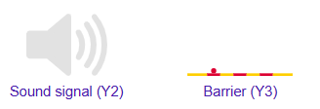

Traffic Hazard driving

* 20% of traffic deaths are related to the use of drugs or alcohol
* 90% of drunk drivers are men – mostly young or middle-aged.
* Your reaction time after a sleepless night is comparable to that of a drunk person.

| Alcohol | Medication | Drugs | Mobile phones |
| --- | --- | --- | --- |
| per mille (‰) = 1‰ = 1 per 1,000 = 1 g. of pure alcohol in every 1,000 gm of blood | Your responsibility to judge whether the medication makes you a traffic hazard | Zero tolerance  Stimulants = Cocaine and amphetamines;  Sedatives = Heroin, opium and morphine;  Hallucinogens = LSD | * **Prohibited to hold phone** while driving * Prohibited to use a mobile phone, fiddle with a GPS device or similar if it makes you a traffic hazard. |
| Drunk driving   * 0.2 per mille (‰) = 0.1 mg of alcohol per litre of breath. * Fine or jail up to 6 months * 1 year license revoked. Repeat cases - 2 years * Serving alcohol to one you know will be driving, or lending car to drunk person = Complicit in drunk driving * Applicable **everywhere**, including fenced-off areas and private property. | Same legislation as **drunk driving**. | Same legislation as **drunk driving**. |
| Aggravated drunk driving   * 1.0 per mille (‰) = 0.5 mg of alcohol per litre of breath. * Jail up to 2 years * License revoked - 2 years - Take tests again |  |  |

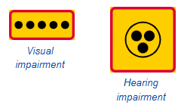

* Visual impairments - White cane
* Signals with the white cane
  + Straight towards the ground: waiting and listening
  + Diagonal: intends to start walking.
* Guide dogs wear a white harness
* 65–74 years old - high degree of maturity and traffic experience
* 75 years and older: Senses impaired which means that they have a 5–6 times higher accident risk (same as 18–19-year-olds)

Children

* School buses have signs with warning lights that the driver turns on 100 metres before a stop and turns off 100 metres after the stop.

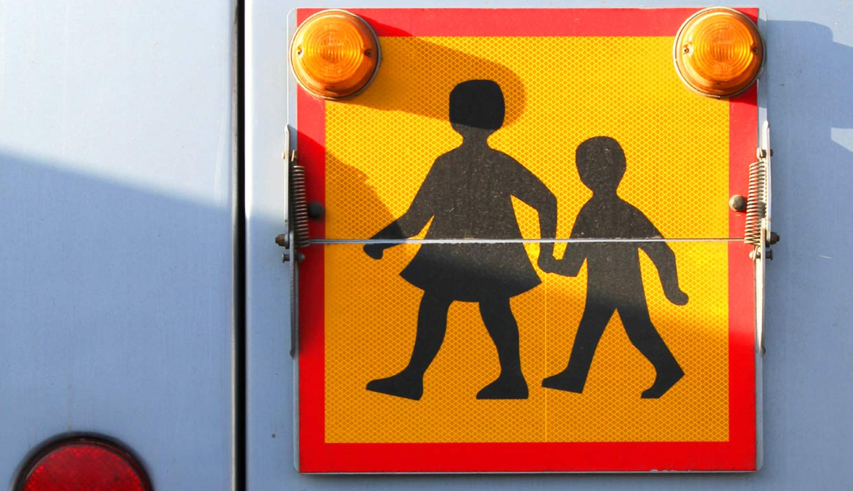

* In Sweden, crossing guards are often children or young people. They wear orange coats with reflectors and stand next to pedestrian crossings. But they have no official powers – for example, they are not authorised to stop traffic.

Accidents

* If the person is not breathing: No pulse - Cardiopulmonary resuscitation (CPR) is required. Has a pulse - Mouth-to-mouth resuscitation.
* Circulatory shock involves life-threatening internal damage (bleeding). The person will often be pale and experience cold-sweats. Make sure the person is breathing properly and do not give them anything to drink.
* If the object you have damaged is a road sign, you must immediately try to restore it. If you are unable to, contact the police and warn other road users.
* Greatest risk of wildlife on the road
  + At dusk and dawn
  + May–June and September–October
  + On salted roads
  + Close to open fields
  + Close to a watercourse
  + At the start and end of a wildlife fence.
* Accidents involving elk are the most dangerous type of wildlife accident.
* If your car stalls on a road/you stop due to an emergency where the speed limit is over 50 km/h, put on hazard warning lights and display a warning triangle. Place it 50–100 metres behind the car.
* Risk of a pedestrian being killed if hit by a car: 10% risk of fatality at 30 km/h. 80% risk of fatality at 50 km/h.

Distances

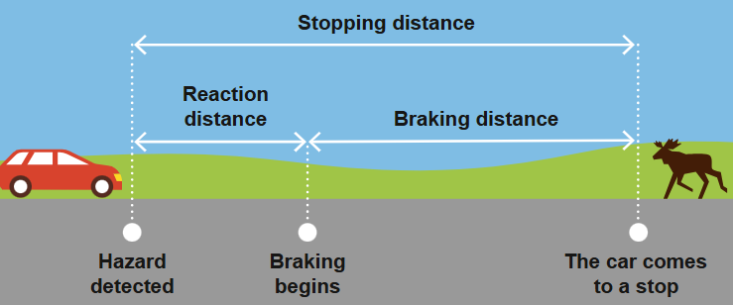

* Reaction
  + Car speed ∝ Reaction distance
    - Reaction distance = Remove the last digit in the speed, multiply by the reaction time and then by 3
  + Your reaction time normally = 0.5–2 seconds
  + 45–54-year-olds have the best reaction time in traffic.
* Braking distance
  + Affected by
    - Car speed (quadratic increase)
      * 2 x higher speed = 4 x longer braking distance
      * 3 x higher speed = 9 x longer braking distance.
    - Road (gradient and conditions)
    - Load
    - Brakes (condition, braking technique and how many wheels are braking).
  + The braking distance may be 10 times longer when there is ice on the road.
  + Breaking distance = Remove the zero from the speed, multiply the figure by itself and then multiply by 0.4

Tyres

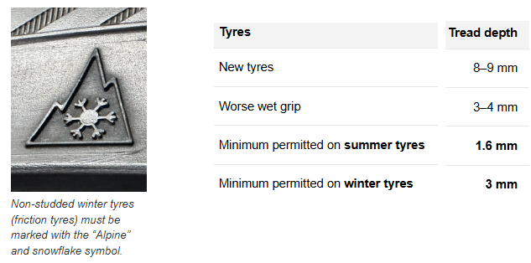

* New tyres
  + Summer tyres : 7-8 mm
    - Safe to change at 3 mm
  + Winter tyres : 9-10 mm
    - Safe to change at 4-5 mm
* Winter tyres
  + Studded tyres:
    - Best on icy surfaces, but cause a lot of wear on the roads.
    - Older cars without anti-skid systems should have studded tyres.
  + Friction tyres:
    - As good as studded tyres, except on ice. But good enough for mild winters and for cars with anti-skid system
    - Friction tyres roll more quietly and wear less on the roads.
    - Driving with friction tyres in the summer can cause dangerous situations, because the rubber in the tyres becomes too soft.
  + Summer tyres with snow chains may be used as an alternative to winter tyres.
* Winter road conditions exist if there is snow, ice, slush, frost on some part of road
* Legally : **Winter tyres in winter road conditions: 1 December–31 March**
* **Prohibited to studded tyres 16 April–30 September unless winter road conditions** as studs rip up particles hazardous to human health

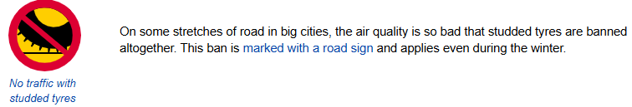

* Year-round tyres are not suitable for use in Sweden
* It is prohibited to combine summer tyres and winter tyres. It is also prohibited to combine studded winter tyres and non-studded winter tyres. Exception: If you get a puncture on a car fitted with winter tyres, you may use a summer spare tyre until the winter tyre has been fixed.
* Change both tyres on the same axle, not just one tyre
  + After changing a tyre, you should re-tighten the wheel bolts after several tens of kilometres of driving in order to reduce the risk of them loosening.
* Tyres are subjected to greater wear at higher speeds
  + Smooth driving is better for the tyres
* Tyre pressure
  + Check tyre pressure once a month. Always measure when tyres are cold.
    - When you drive: Tyres get hot -> Hot air expands Pressure increases temporarily -> false high pressure reading
  + Correct pressure is mentioned in the instruction manual.
  + Wrong pressure can increase fuel consumption, shorten tyre life and lengthen barking distance
* Retreaded tyres are used tyres that have been fitted with new treads - cheaper but worse than new tyres
* Incorrect **wheel alignment** causes the car to **pull** to one side if you hold the steering wheel loosely on a straight road. This leads to uneven **wear** on the tyres. It can be caused by the tyres **bumping** into something.
* Incorrect **balancing** causes the steering wheel to **vibrate** occasionally. This leads to increased tyre **wear**.
* A regular spare tyre is exactly the same type of tyre that the car normally has.
* A temporary spare is a narrower tyre version that is only suitable for use in order to get the car to a workshop. The car’s user manual contains instructions regarding the maximum speed, maximum distance and the air pressure for the temporary spare.
* If any one should have studded tyres, it’s always the trailer attached to the car even if the car does not have studded tyres. This is to avoid the risk of jack-knifing, which occurs when the car has better grip than the trailer during braking. The result will be that the trailer skids to the side in an uncontrolled manner
* Side force
  + When you turn, the tyres must push the car sideways. If you go faster, they can’t push enough → you slide.
  + Side force = the tyres’ ability to push the car sideways in a curve

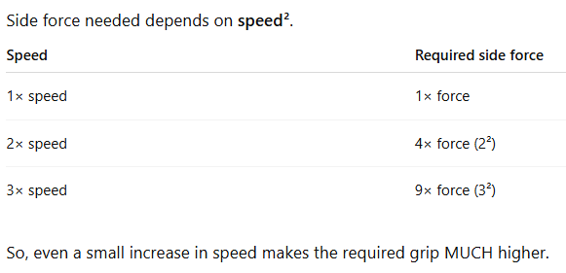

* Roadholding (Grip)
  + Grip = friction between tyres and the road = what keeps the car from sliding.
  + You need enough grip to: turn safely, brake safely, accelerate without spinning
  + Less grip : Worn/bad tyres, wet roads, new asphalt (oily), gravel, mud

Steering

| Oversteering | Understeering (safer than O) |
| --- | --- |
| Car turns too **much** as the **back tyres** lose grip -> Rear-wheel slide (fishtailing) | Car turns too **little** as the **front tyres** lose grip. |
| Normally affects **rear-wheel** drive cars -> So, put the best tyres at the back | Normally affects **front-wheel** drive cars (Most new cars have front-wheel drive) |
| Causes of oversteering :   * Back tyres problems   + Aqp -> lose grip   + Tail-heavy car (too heavy a load at the rear)   + Insufficient air in both   + Worn tires * Forceful braking * Forceful acceleration with a rear-wheel drive car * Trailer/Caravan * Crosswind | Causes of understeering :   * Front tyres problems   + Aqp -> Lose grip   + Nose-heavy car (too heavy a load at the front)   + Insufficient air in both     - One has low air -> Car pulls diagonally   + Worn tires * Braking without ABS brakes * Forceful acceleration in a front-wheel drive car * Trailer/Caravan * Locked differential (the wheels are forced to move at the same speed on bends) |

* Steering system
  + Power steering is a system that makes it easier to turn the wheel
  + Choppy steering probably indicates that dirt or air has entered the servo
  + Shaky steering wheel is normally caused by imbalance in the front wheels or looseness in the steering mechanism
* ESC-system (Electronic stability control) - also called anti-skid/anti-spin system/DSTC (Dynamic Stability and Traction Control)/ESP (ES Program)
  + A computer with sensors detects whether a wheel is spinning or if the car is hastily turned in a certain direction.
  + The computer uses this information to calculate the best measure for resolving the situation (e.g. applying brakes to one of the wheels).

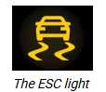

Car brake system

* **Dual-circuit brake system** means that the braking system is divided into two independent parts. If one circuit (brake for two wheels) fails, the second circuit (remaining two wheels) functions as normal. It’s a common feature in cars
* Main braking system

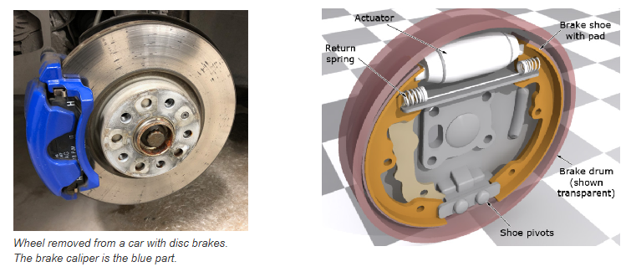

* + When you press the brake pedal (footbrakes/service brakes) , the **hydraulic** system moves the brake fluid, which then applies pressure to disc/drum brakes to stop the car.
  + One problem with brake fluid is that it attracts moisture/water which affects braking. So it should be changed every two years.
  + Most common brakes in new cars are **disc brakes** which have an open brake disc and a caliper that is pressed against the disc when you brake
  + **Drum brakes** have a round drum. Inside the drum are brake shoes which are pressed against the drum when you brake.
* Additional braking system - Ex: Anti-lock brakes (ABS) brakes
  + They help with car control during forceful braking. The braking distance can be decreased, but in certain cases may be increased (e.g. on gravel)
  + It makes sure the wheels don’t lock up when you brake hard.
  + ABS works by monitoring the wheel speed and if the system detects any wheel is about to lock, it adjusts brake pressure to keep the wheel turning. This allows the car to keep control and helps you steer
  + When you brake hard in a car that is fitted with ABS, the pedal may begin to stutter and pulsate (it sounds as if something is wrong). This is entirely normal, however, as this is how the ABS system works.

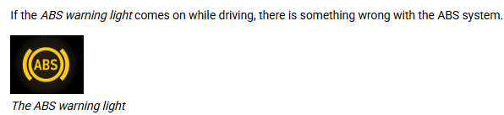

* Faulty brakes test with engine ON - Press the pedal down hard for 20 seconds
  + If the brake pedal sinks very low, this indicates wear.
  + If the pedal continues to sink slowly, despite the fact that you have reached the bottom, this means there is probably a leak in the brake system. This poses a very serious traffic hazard and must be rectified immediately.
  + If the pedal feels springy, this may be due to air in the brake system. Take the car to a workshop to have this rectified.
  + It is especially important to test the brakes after washing the car, as water can have a negative effect on them. Forceful, controlled braking will dry up the moisture.
* Brake servo
  + When you press the brake pedal, the brake servo makes it easier to move the pedal down.The brake servo only works when the engine is running.
  + Test to see if the brake servo is working: Pump the brake pedal a few times with the engine switched off. Start the car with the brake pedal depressed. If the pedal sinks when the engine starts, the servo is working as it should.
* Parking Brake (Hand brake/Emergency brake)
  + It is there to stop the car from rolling when it is parked.
  + When you engage it, it applies force to the rear brakes, locking the wheels so the car doesn’t move
  + The electronic system may have automatic release features, where the brake disengages when you press the accelerator or shift into drive.
  + There is a risk that it may freeze in place in cold, damp weather. It may seize up if you do not use it regularly
  + Check to see whether the parking brake is working (does not work with electronic parking brake): Set the car rolling down a hill and then pull on the brake. Try to drive with the brake on.
* Brake fluid level

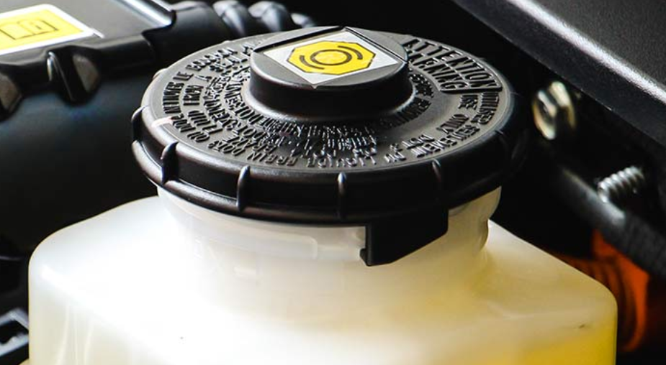

* Check level occasionally
* Replace every 2 years

Kinetic energy

* Energy an object has because it’s moving.
* **Kinetic energy = mass × (speed)²** (in simple terms)
  + More mass → more energy. More speed → *much more* energy.
  + At high speed you need much more distance and grip to stop or change direction safely.

Alternator

* A makes electricity while the engine is running. It changes mechanical energy (movement) into electrical energy, which is then stored in the car’s battery. This electricity powers things like your lights, radio, and dashboard systems.
* It works using a **belt** that spins when the engine runs and this belt needs to be in good condition. Otherwise, you could hear a squealing sound, lose electrical power, or even overheat the engine.

Cooling system

* Control engine’s temperature
* Coolant temperature is shown in Engine Temp gauge (good to be at center when engine is running)

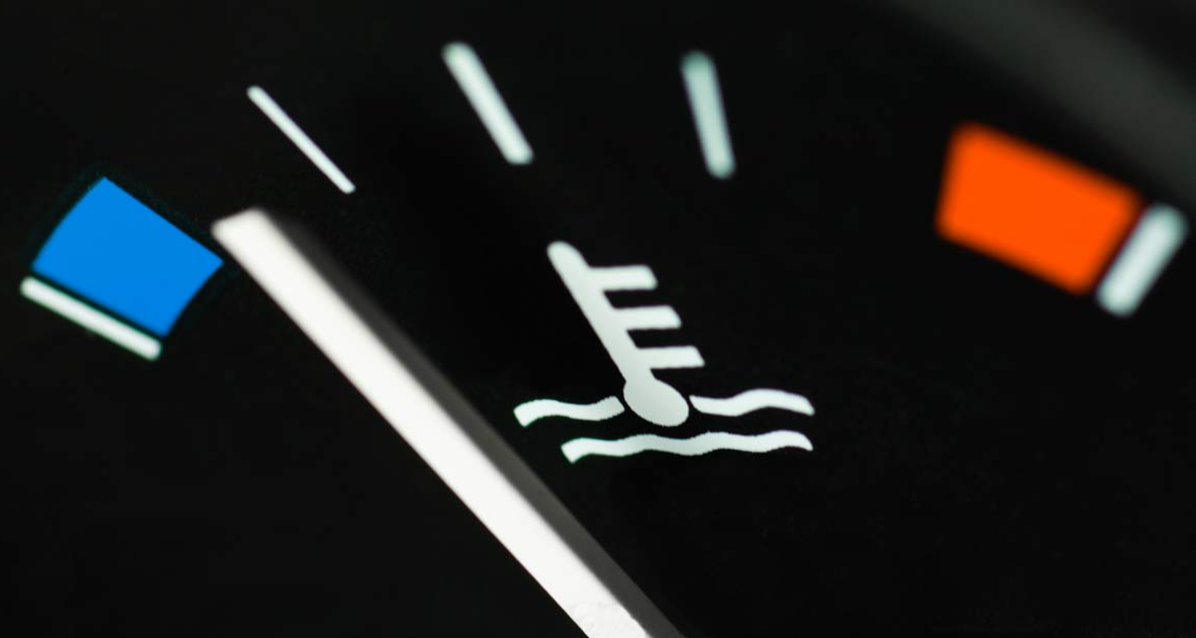

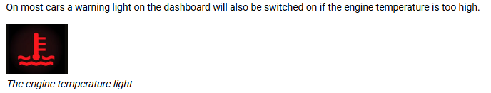

* Coolant fluid
  + It has half water and half glycol, and can withstand temp. Till -35°C
    - Glycol prevents freezing and protects against rust - but toxic

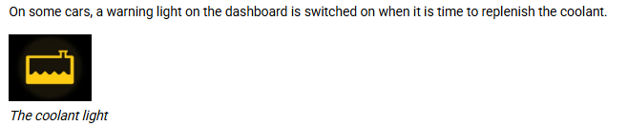

* + If engine temp is high, wait for the engine to cool down and check the coolant level (else vapour can scald you)

Fuel system

* Engine mixes fuel with air to create combustion (-> car moves)
  + That air should be clean else it can damage the engine and increase fuel consumption
  + The air filter cleans the air. So ensure filter is not clogged

Lubrication system

* For engine to work, it needs engine oil to lubricate, cool engine, protect against rust, reduces engine vibration and noise, and clean engine
* Check oil level regularly using dipstick (min-max is 1 litre)
* Stop the car if you see warning light

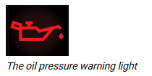

Crash safety

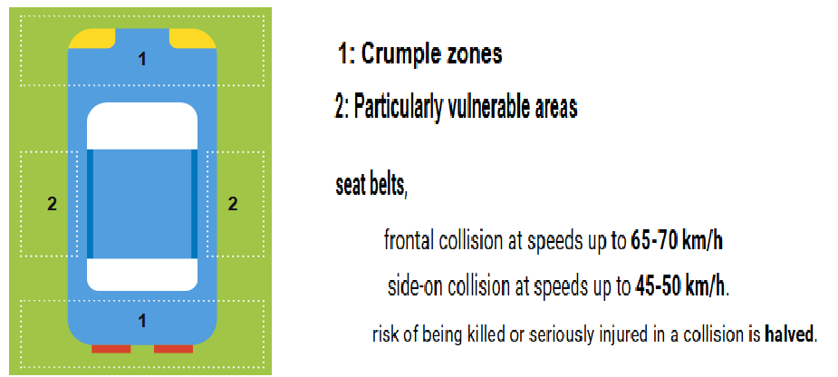

* **Belt tensioners** (found in newer cars) is an automatic system that pulls the belt hard in the event of a crash. This means that you are better protected.
* Airbag mainly protects face and chest
  + Driver - Sit at least 25 cm from the airbag – else it can injure during inflation
    - Passengers - atleast 50 cm
  + It takes just 0.1 seconds for the airbag to fill up
  + Triggered at speeds over 20–30 km/h
* Whiplash injuries are common in rear-end collisions. If you realize that car is gonna get hit from the back, press your head against head restraint and look ahead

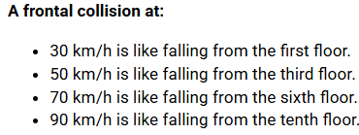

* If no seat belt, one can manage collisions upto 7 km/h. Seat belt is not required when
  + Reversing
  + Driving in parking lot/petrol station/workshop area
  + Medical certificate

Child safety seats

* Driver is responsible for passengers under the age of 15 using a seat belt

| Baby car seat | Rear-facing seat | Booster seat | No child seat | Like Adult |
| --- | --- | --- | --- | --- |
| 0–9 months old or until the child sits steadily | 7 mon - 4 years or until the child’s head reaches the edge of the seat | 4 years - 135 cm tall | At a height of 135 cm but not in a seat with an airbag. | At a height of 140 cm |
|  | Front-facing child safety seats exist, but the rear-facing type is preferable from a safety viewpoint. | The back seat offers the safest placement. |  |  |
| Exception 1:  Occasional trips in the back seats of taxis are permitted if the child is under 3 years old.  Exception 2:  Occasional trips over short distances for children over 3 years old and under 135 cm are permitted if the child sits in the back seat with a seat belt on. | | |  |  |

Besiktning (Inspection/roadworthiness test) :

* Compulsory -> Else driving ban
* Rectify faults identified under B -> Else driving ban
* Done regularly to reduce the number of accidents caused by technical faults, and to prevent excessive emissions of harmful substances.
  + New car B = 3 years (before end of month) after registration date
    - 2nd B = 2 years (before end of month) from the 1st B
    - Subsequent B = Every 14 months (before end of month)
* What is checked
  + Frame – that the car’s load-bearing structure has not been damaged by, for example, severe rusting.
  + Wheels and control system
  + Tyres’ condition and tread depth
  + Drive system – the engine, and the electrical, exhaust and drive systems.
  + Brake system – the function, effectiveness and evenness of the brakes.
  + Bodywork – seat belts, windows and doors
  + Communication – lights, indicators, horn, windscreen washer fluid and warning triangle.
  + Environment – the exhaust emissions are compared with threshold values.
  + Other – towbar, instrument lights and speedometer.
* Flygande inspektion (Spot inspection) - A police officer or vehicle inspector has the right to check a vehicle at any time
* Registrering besiktning - If the vehicle changes (for example, if the engine is replaced), it must be subjected to a registration inspection within 1 month

Length and width of car

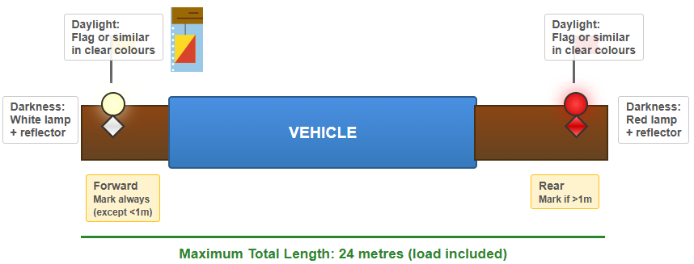

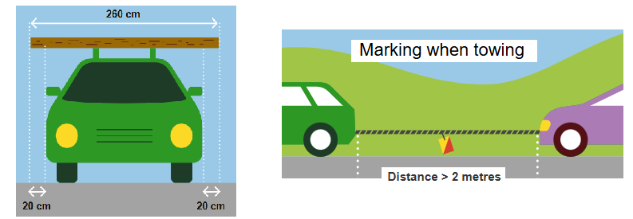

Trailer

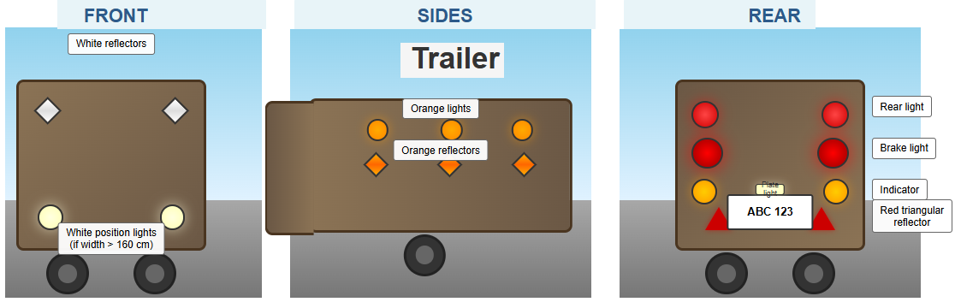

* Load
  + Secure the load
  + Position the load right at the front of the boot(i.e., against the back seat)
  + Position the heaviest part of the load at the bottom
  + Load is subjected to high pressure during breaking. So, fastening should withstand 80% of the cargo weight in a forward direction and 50% of the cargo weight in a backwards direction and to the sides.
* Brakes
  + Service brake must be fitted on trailers with a **total weight** exceeding **750** kg
  + Parking brake must be on trailers with an **unladen weight** exceeding **400** kg.

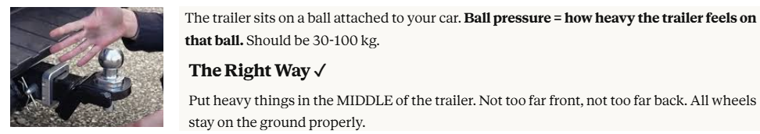

| High ball pressure | Low ball pressure (Can -> DRIVING BAN) |
| --- | --- |
|  |  |
|  | Can -> DRIVING BAN |
| Why: You put too much stuff in the FRONT of the trailer | Why: You put too much stuff in the BACK of the trailer. |
| What happens:   * Trailer pushes DOWN on the ball * Car's FRONT lifts up (back down) * Headlights point up = you blind other drivers | What happens:   * Trailer lifts UP (like it's tipping over backwards) * This pulls car's BACK end up |

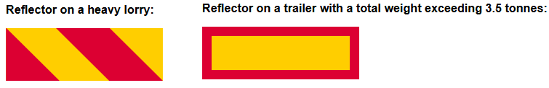

Basic service of car :

* Battery



* + If your car battery light comes on when you start the car and then turns off shortly after, you're in the clear!
  + If the light stays on as you’re driving, though, pay attention as there can be electrical problems
* Fuses
  + Protect the car’s electrical system from being damaged by an overload.
  + If something electrical stops working suddenly, we may need to replace a fuse
  + Fuses are usually in a box either in the engine compartment or under the dashboard
* Radiator
  + Prevents the engine from overheating.
  + Do not open the radiator when the engine is warm as it may release very hot steam and burn you
  + Radiator must be replenished with coolant, which has water and glycol.
* Engine oil

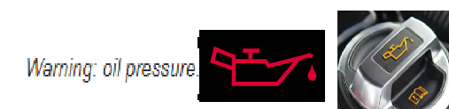

* + Engine oil is used to lubricate the engine so that none of its parts seize up.
  + Level is checked using the dipstick
* Windshield washer fluid
  + It can be bought as diluted or concentrated (dilute with 1 part concentrate + 2 parts water)

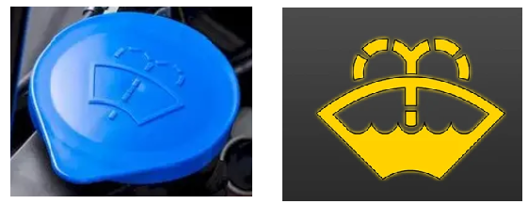

* Windshield defrosters/defoggers/demisters

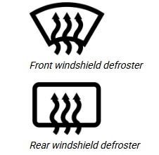

* Jump start a car
  + If the battery is discharged, the car will not start. Then you’ll need to jump-start the car

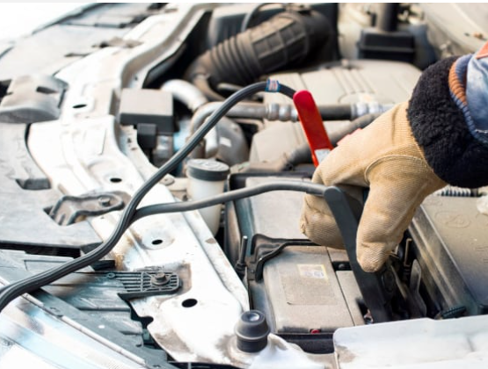

1. Connect the red jump lead (+ terminal)
2. Connect the black jump lead (- terminal))
3. Start the assisting car
4. Start problematic car (few attempts not too many as it damages catalytic converter)
5. Let both cars run
6. Turn off and disconnect in reverse order
   1. Remove the black jump lead of problematic car
   2. Remove the black jump lead of assisting car
   3. Remove red cable

Insurance

* Home insurance - can provide you with compensation if you have been injured in an accident, lost baggage etc.
* Car insurance - 3 levels

| Third-party insurance | Partial insurance | Fully-comprehensive insurance (motor vehicle damage insurance) |
| --- | --- | --- |
| Obligatory | TP + below | TP + PI + below |
| * Personal injury * Damage to other’s car/property ( not not own car) | * Theft or attempted theft damage * Fire – if the car begins to burn * Glass * Machine – if the engine breaks down * Legal costs | * Damage to car due to accidents. * Scratches and dents * Vandalism. * Salvage and towing. |
| If you have not submitted any claims for many years, you can receive a cheaper third-party insurance premium through a no-claims bonus. |  |  |
| If you are penalised for reckless driving or drunk driving, the insurance company may claim money back from you (right of recourse). |  |  |

Car registration certificate (registreringsbevis av Transportstyrelsen)

* 2 parts
  + Part 1 - BLUE - Technical information about the vehicle
    - Need it if you drive outside Sweden
  + Part 2 - YELLOW - Certificate of ownership and change of ownership
    - Valuable -> Dont keep it in car
* Off-road status
  + By registering your car as being off the road, you avoid having to pay vehicle tax and third-party insurance.
  + Driving ban -> actively submit an off-road notification yourself
  + Can only be driven to and from besiktning, provided that third-party insurance has been paid, and there are no motor vehicle tax arrears.
  + Forbidden to tow a vehicle with off-road status.

Mopeds

| Class I (EU) moped | Class 2 moped |
| --- | --- |
| 2-4 wheels - Max 45 kmph | 2-4 wheels - Max 25 kmph and engine power <= 1 KW |
| Registered -> License plate | Can run with no registration |
| Not driven on cycle paths | Rules are same as for bicycles |

**B-license**

